Class # 2 – Creating Effective Electronic Presentations Using PowerPoint

1. Download files on my website and examples Contents of my CD “Examples”
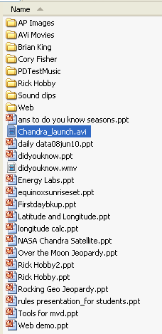
of assignment #1 and assignment #2
2. Review of the draw tools and how are they used with PowerPoint
3. Starting a PowerPoint Presentation
4. From the “Format” Menu, choose “Slide Layout”
5. Type Text into the text boxes provided (Use CTRL M for “More”). Check out the slide layouts
6. From the “Format” Menu, choose “Slide Design” (right click on a slide in the Slide Design Task Bar to change the design of one or all of the slides in your presentation).
7. From the “Slideshow” Menu choose “Slide Transition”.
8. From the “Slideshow Menu” choose “Custom Animation”. This is more powerful than the animation schemes. You control everything.
9. From the “Insert” menu, choose “picture”, then choose “Clipart”.
10. What are an entrance, emphasis, and an exit animation?
11. What is meant by motion paths?
10. Use the methods you used while reviewing the draw tools and things we covered in this class to complete your first assignment.
11. How do I add a soundtrack to my PowerPoint presentation?
12. Begin assignment #2

Coming up – Using Audacity to create a custom soundtrack to add to your presentations!

Contents of my CD “PTT Templates”

